1) x+~xy = x+y
x | y | ~x | ~xy | x+~xy | x+y
0 | 0 | 1 | 0 | 0 | 0
0 | 1 | 1 | 1 | 1 | 1
1 | 0 | 0 | 0 | 1 | 1
1 | 1 | 0 | 0 | 1 | 1

2)
- AB!CD
- A!BC!D
- !A!D
- A

3) Sum of product: !ABC + A!BC + AB!C + ABC
After K-Map: AB + AC + BC

5) NOT circuit
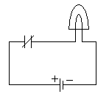

6) NAND circuit
